PROMISE & PRACTICE · DEEP DIVE · SOURCE ANALYSIS
The Overland Campaign — A House Divided
Grant's Brutal Arithmetic
Name: ______________________________ Period: _____ Date: ________________
WHAT I CAN DO TODAY I can read primary sources about The Overland Campaign — A House Divided, weigh who made each one and why, and use evidence to answer historical questions.
Directions. Numbers can carry an argument. Read the casualty data, then judge Grant's strategy

THE SOURCES
DATA SET · THE OVERLAND CAMPAIGN, MAY–JUNE 1864 — Approximate casualties (killed, wounded, captured, missing)
Battle Union Confederate
The Wilderness ~17,500 ~11,000
Spotsylvania ~18,000 ~12,000
Cold Harbor ~12,000 ~5,000
Six-week total (approx.) ~55,000 ~33,000.
Standard historical estimates, rounded. Public domain data.
THE IMAGE · MAY 1864 — Grant's Council of War
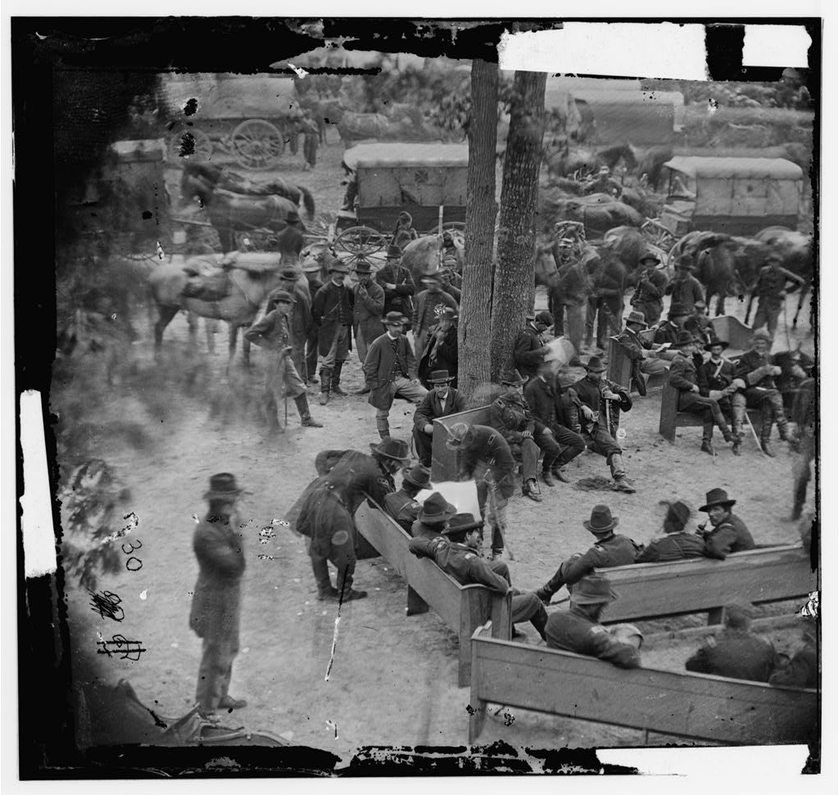
General Grant's “Council of War” at Massaponax Church, Virginia — photograph, May 1864, public domain (Library of Congress).

YOUR WORK
QUESTION 1 STEP 1 · READ THE TABLE
Grant's army lost more men than Lee's in every battle. So why do historians say this campaign hurt the Confederacy more? (Hint: think about which side could replace its losses.)
____________________________________________________________________________________________
____________________________________________________________________________________________
____________________________________________________________________________________________
QUESTION 2 STEP 2 · THE STRATEGY
What did Grant do after each bloody battle that earlier Union generals had not done?
☐ A. he surrendered
☐ B. he kept advancing south instead of retreating
☐ C. he went home for the winter
☐ D. he avoided Lee's army entirely
QUESTION 3 STEP 3 · DEFINE THE TERM
In your own words, define a war of attrition, and explain why it favored the Union even though the Union took heavier losses.
____________________________________________________________________________________________
____________________________________________________________________________________________
____________________________________________________________________________________________
QUESTION 4 STEP 4 · MAKE THE CALL
Northern papers called Grant a “butcher.” Others say he was the first general who truly knew how to win. Using the data, argue which view is fairer — in three or four sentences.
____________________________________________________________________________________________
____________________________________________________________________________________________
____________________________________________________________________________________________
____________________________________________________________________________________________
____________________________________________________________________________________________
Promise & Practice · ShadowDog Digital Studios · Unit 2

TEACHER ANSWER KEY — The Overland Campaign — A House Divided

QUESTION 1: Open response.
Look for a response along the lines of: “Even though the Union lost more, it hurt the South more because…”
QUESTION 2: Correct — B. he kept advancing south instead of retreating
Right. Grant kept pushing south after every battle instead of retreating. He refused to give Lee a chance to recover — the essence of a war of attrition.
QUESTION 3: Open response.
Look for a response along the lines of: “A war of attrition means…. It favored the Union because…”
QUESTION 4: Open response.
Look for a response along the lines of: “I think Grant was ___ because the numbers show…”

